CT Slice Localization: Feature Selection and Dimensionality Reduction Study
Progress report and mathematical foundations. Status as of 27 October 2026.
This document records what has been done so far and the mathematics behind every technique used. Every number comes from the result files produced by the reference pipeline (ct_study.py). Numbers marked derived are simple arithmetic on those files. Nothing here is a new experiment.

1. Summary of work so far
Item | Status
Dataset loaded and inspected | Done: 53,500 rows, 386 columns, 97 patients
Stage 1 EDA
Experimental protocol | Reference defaults used (patient-grouped 5-fold CV, Ridge and HGB benchmarks)
Baseline (all features) | Computed in CV and on the held-out test patients
Feature selection | 11 methods run (5 filter, 2 wrapper, 4 embedded)
Dimensionality reduction | PCA, PLS and binned-target LDA run; t-SNE/UMAP for visualization only.
Stability and statistics | Jaccard, Kuncheva, selection frequency; corrected paired tests with Holm correction
Final test evaluation | Run once, as a dry run (see Section 13 on test-set reuse)

2. Dataset and exploratory findings

2.1 Structure
Each row is one axial CT slice. Columns are patientId, value0–value383 and reference. Features value0–value239 form the bone histogram and value240–value383 the air-inclusion histogram, both in polar space. The target reference is the relative position of the slice along the body axis.
A value of −0.25 marks a bin outside the image. It is a flag, not a measurement, and it sits in the same columns as real values.

2.2 Split
63 exact duplicate rows were removed, leaving 53,437 rows. Patients were then split: 77 development patients (43,275 rows) and 20 held-out test patients (10,162 rows). The EDA below uses development data only.

2.3 EDA results (development set)
Quantity | Value | Why it matters
Missing values | 0 | But −0.25 acts as a hidden "outside image" code
Target range, mean, SD, skew | 1.74–97.49, 47.85, 22.46, 0.27 | Continuous target, so regression
Constant columns | 5 | Carry no information; dropped inside each fold
Near-zero-variance columns (<1e−4) | 1 | Likely the reason one CV fold had 378 surviving columns
Columns with ≤5 distinct values | 31 | Highly discrete features
Share of cells equal to −0.25 | bone 17.7%, air 13.5% | Sentinel must be handled deliberately
Share of cells equal to 0 | bone 62.7%, air 69.0% | Sparse features
Rows per patient (min, median, max) | 66, 510, 1749 | Unequal patient sizes affect fold balance
η² of target by patient | 0.472 | Patient identity explains 47% of target variance
Median target gap between adjacent rows of the same patient | 1.34 | Neighbouring slices are near-duplicates
Feature pairs with absolute Spearman correlation above 0.95 | 190 | Strong redundancy
Principal components for 95% variance (standardised) | 207 | Redundancy is not low-rank
Condition number of the correlation matrix | 5.6e13 | Nearly singular; unregularised least squares is unstable
The problem is formulated as regression: the target is continuosus with about 53,000 distinct values.
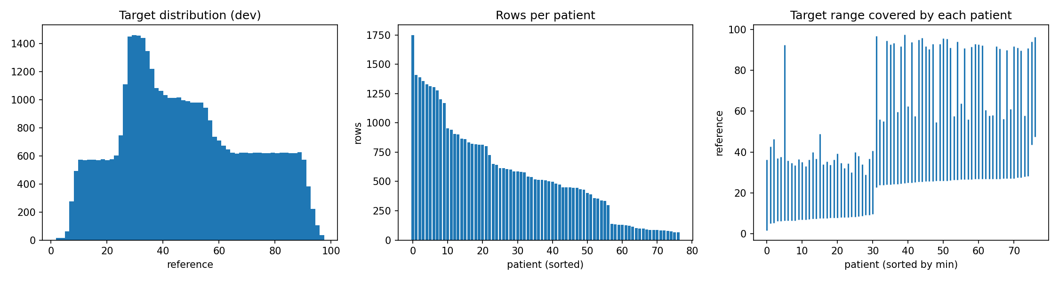
Figure 1: eda_target_patients
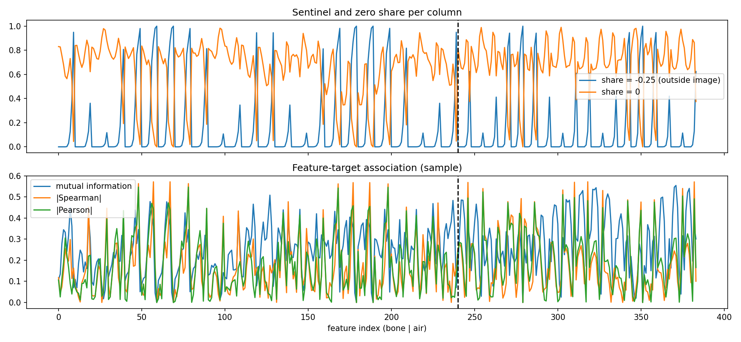
Figure 2: eda_sentinel_association
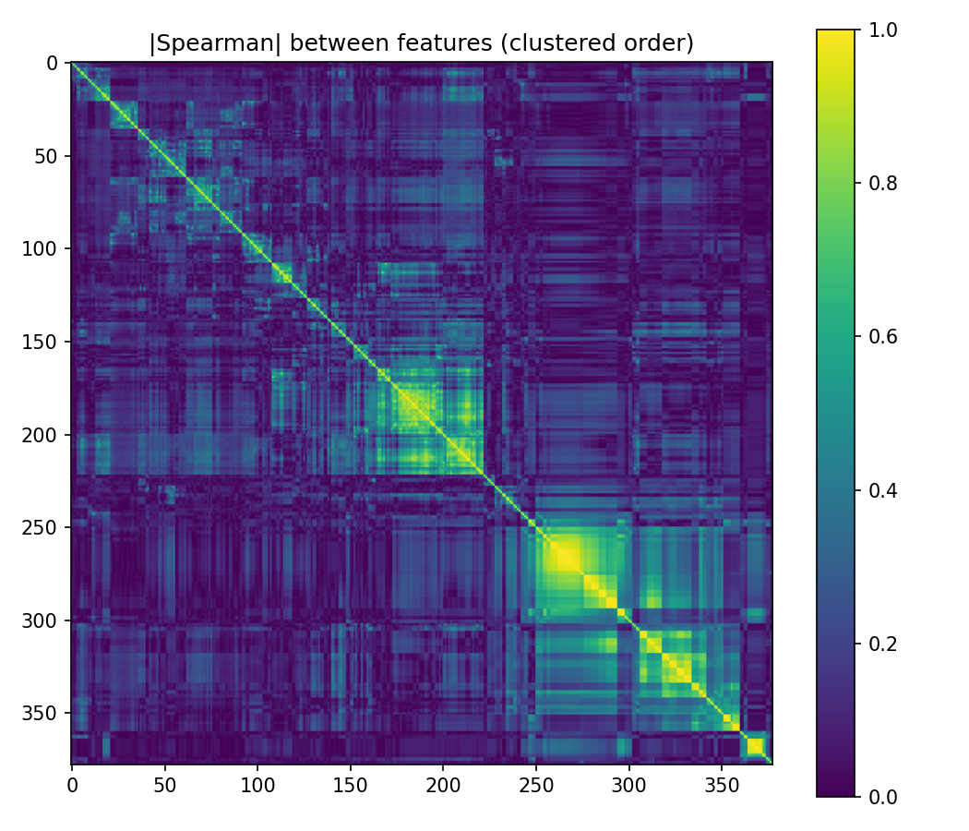
Figure 3: eda_corr_clustered

3. Experimental protocol
- Patient-level test split. Test patients are held out before any analysis and used only once.
- Patient-grouped cross-validation. Folds partition patients, so slices of one patient never appear in both training and validation. Without this, near-identical neighbouring slices leak between train and validation and inflate scores.
- Fold-internal preprocessing. In every fold: drop columns constant in the training part, then standardise with training means and standard deviations. Selection and extraction are also fitted on training data only.
- Ranking then top-k. Each selector ranks features on the training fold; the top-k are then evaluated for every k in the grid, and the selected sets are stored for stability analysis.
- Inner tuning. Ridge's penalty is tuned by an inner grouped 3-fold CV on the training fold.
- Settings used. The CV outputs show 5 splits per configuration, so one repeat of 5-fold CV. The k grid was 5, 10, 20, 40, 80, 160, with PCA/PLS component counts up to 80 and LDA capped at 9.
Standardisation. For feature j:
zᵢⱼ = (xᵢⱼ − μⱼ) / σⱼ, μⱼ and σⱼ computed on the training fold only
A column with σⱼ = 0 cannot be standardised, which is why constant columns are dropped first.

4. Evaluation metrics
For n validation observations with targets yᵢ, predictions ŷᵢ and mean ȳ:
MAE = (1/n) ∑ |yᵢ − ŷᵢ|
RMSE = √[ (1/n) ∑ (yᵢ − ŷᵢ)² ]
R² = 1 − ∑ (yᵢ − ŷᵢ)² / ∑ (yᵢ − ȳ)²
- MAE is in target units and weights all errors linearly. It is the loss minimised by the conditional median.
- RMSE is in target units but squares errors, so a few large mistakes dominate. It is the loss minimised by the conditional mean.
- R² compares the model with always predicting the validation mean. It is dimensionless and can be negative. A model with lower MAE and higher RMSE than another has more heavy-tailed errors.
- Limitations. All three average over rows, so patients with many slices carry more weight. The 77 patients, not the 43,275 rows, are the real unit of replication.
A mean-predictor reference gives an interpretable floor. In CV it scored RMSE 22.55 and R² −0.03.

5. Benchmark models

5.1 Ridge regression (linear benchmark)
For centred data with design matrix X (n×p) and target y:
ŵ = argmin_w ‖y − Xw‖₂² + α ‖w‖₂² ⇒ ŵ = (XᵀX + αI)⁻¹ Xᵀy
With the SVD X = UΣVᵀ, the fitted coefficient along singular direction i is shrunk by the factor σᵢ² / (σᵢ² + α). Directions with small singular values, which are the redundant directions of collinear features, are shrunk hardest. This matters here because the correlation matrix has condition number 5.6e13: ordinary least squares would be numerically unstable. The penalty α was chosen from {0.1, 1, 10, 100, 1000}.
Assumptions and limits. Linear in the standardised features, and the L2 penalty gives no exact zeros, so Ridge alone does not select features.

5.2 Histogram gradient boosting (nonlinear benchmark)
Boosting builds an additive model by stagewise fitting. For squared loss:
Fₘ(x) = Fₘ₋₁(x) + ν · hₘ(x), hₘ fits the residuals rᵢ = yᵢ − Fₘ₋₁(xᵢ)
Here hₘ is a small regression tree and ν the learning rate. Residuals are the negative gradient of the squared loss, which is why this generalises to other losses as gradient descent in function space. The histogram variant bins each feature into at most 256 values to make split-finding fast. Settings used: 200 iterations, learning rate 0.1, no early stopping. Trees are invariant to monotone feature rescaling and can capture interactions, which Ridge cannot.
Using two benchmark models tests whether conclusions about a selector depend on the model.

6. Filter methods
Filters score each feature without training the final model. They are fast but, scored one feature at a time, they ignore redundancy between features.

6.1 Variance threshold
Var(xⱼ) = (1/n) ∑ (xᵢⱼ − x̄ⱼ)²
The script ranks features by raw (unscaled) variance on the training fold, because after standardisation every variance equals 1. It is unsupervised, so it never uses the target. It is also scale-dependent: a feature measured in larger units looks more informative. Here all features lie in [−0.25, 1], so the scale issue is mild, but the sentinel value inflates the variance of columns with many out-of-image bins.

6.2 Pearson correlation and the F-test
rⱼ = Cov(xⱼ, y) / (σ_xj · σ_y)
For simple linear regression of y on one feature, the F-statistic is:
Fⱼ = rⱼ² / (1 − rⱼ²) · (n − 2) ~ F(1, n−2) under H₀: no linear relationship
Key consequence: Fⱼ is a strictly increasing function of |rⱼ|, so ranking by the F-statistic and ranking by absolute Pearson correlation give the same order. The two methods are not independent experiments.
Assumptions. Linear association, roughly Gaussian errors, and independent observations. The last fails here: slices of a patient are strongly dependent, so p-values are overconfident. Used only for ranking, this matters less, but the p-values themselves should not be reported.
Chi-square is not applicable. It tests dependence between a categorical target and non-negative features. This target is continuous and the features contain −0.25.

6.3 Spearman rank correlation
Spearman's ρ is Pearson correlation computed on ranks:
ρⱼ = Pearson( rank(xⱼ), rank(y) ) (= 1 − 6∑dᵢ² / [n(n²−1)] when there are no ties)
It detects any monotonic relationship, not only linear ones. With many exact zeros there are heavy ties, so average ranks are used. It still cannot detect non-monotonic dependence.

6.4 Mutual information
Entropy and conditional entropy (discrete case):
H(X) = − ∑ₓ p(x) log p(x)
H(X|Y) = − ∑ᵧ p(y) ∑ₓ p(x|y) log p(x|y)
Mutual information is the reduction in uncertainty about X from knowing Y:
I(X;Y) = H(X) − H(X|Y)
Derivation of the equivalent forms. Using p(x|y) = p(x,y)/p(y):
H(X) − H(X|Y) = −∑ p(x,y) log p(x) + ∑ p(x,y) log p(x|y)
= ∑ p(x,y) log [ p(x|y) / p(x) ]
= ∑ p(x,y) log [ p(x,y) / (p(x) p(y)) ]
= KL( p(x,y) ‖ p(x)p(y) ) ≥ 0
So I(X;Y) = 0 exactly when X and Y are independent, and by symmetry I(X;Y) = H(X) + H(Y) − H(X,Y). For jointly Gaussian variables, I(X;Y) = −½ log(1 − ρ²), so MI contains correlation as a special case.
Nonlinear dependence. If X is symmetric about zero and Y = X², the Pearson correlation is 0 but I(X;Y) > 0. MI detects any dependence, linear or not.
Estimation for continuous data. The script uses scikit-learn's k-nearest-neighbour estimator, a variant of Kraskov, Stögbauer and Grassberger (2004). Roughly:
Î(X;Y) = ψ(k) + ψ(N) − ⟨ ψ(nₓ + 1) + ψ(nᵧ + 1) ⟩
where ψ is the digamma function, k the number of neighbours (3 here), εᵢ the distance from point i to its k-th neighbour in the joint space, and nₓ, nᵧ the numbers of points within εᵢ in each marginal space. Estimates are noisy and sensitive to ties; this data has many exact zeros, so scikit-learn adds tiny noise to break ties. For speed the script estimates MI on a random subsample of 5,000 training rows.
Limitation. Ranking features by I(Xⱼ;Y) one at a time ignores redundancy. Two near-copies of an informative feature both score high, yet together add little beyond one of them. Joint information is not additive: I(X₁,X₂;Y) ≤ I(X₁;Y) + I(X₂;Y) when the features are redundant. Criteria such as minimum-redundancy maximum-relevance (mRMR) subtract a redundancy term to address this.

6.5 Correlation-based redundancy filter
The script's version is greedy and relevance-ordered:
- Compute relevance |rⱼ| with the target and the absolute feature correlation matrix C on a training subsample.
- Visit features in decreasing relevance. Keep feature j only if max over already-kept features s of |Cⱼₛ| is below the threshold (0.95 here).
- Rank kept features first, in order of relevance, then the rejected ones.
It removes near-duplicates but depends on the threshold and on the order of visiting, so it is a heuristic, not an optimum.

7. Wrapper methods
Wrappers evaluate candidate feature subsets by training a model on them. They can account for redundancy and interactions, at much higher computational cost, and they can overfit the evaluation if it is not designed carefully.

7.1 Recursive Feature Elimination (RFE)
Backward elimination driven by a model's coefficients (Guyon et al., 2002). With X standardised, the importance of feature j is the magnitude of its coefficient in a Ridge fit (α = 10):
Repeat until one feature remains:
fit Ridge on the active features
importance_j = |ŵ_j|
remove the n_drop least important features, n_drop = max(1, floor(0.10 · |active|))
Ranking = reverse order of elimination (eliminated last = best)
The standard library version removes a fixed number per round, which leaves ties at the top of the ranking. The script's 10%-of-remaining schedule gives a strict order down to the last feature. With p ≈ 379 features this needs roughly 40 to 60 Ridge fits, each costing about O(np² + p³).
Why it can work. Refitting after each removal lets the model reallocate weight between correlated features, which a one-shot ranking cannot do.
Limitations. Under strong collinearity the weight is shared arbitrarily among near-duplicates, so |ŵⱼ| is a poor importance measure and the choice among duplicates is unstable. This is consistent with RFE having the lowest selection stability at k = 40 (Section 12.4). The estimator also shapes the result: a Ridge-ranked subset favours linear structure, which may disadvantage a nonlinear downstream model.

7.2 Sequential Forward Selection (SFS)
Greedy forward search over a candidate pool P, scoring each subset by inner grouped CV error:
S ← ∅
for t = 1 … k_max:
j* = argmin_{j ∈ P \ S} CVRMSE( Ridge on S ∪ {j} )
S ← S ∪ {j*}
The number of model fits is 3 · ∑ₜ (|P| − t + 1) over t = 1 … k_max (3 inner folds). Searching all 379 features directly would cost far more, so the script restricts P to the top candidates by F-test.
Limitations. Greedy search is not optimal: a feature that is only useful in combination with another may never be chosen, and a chosen feature can never be removed. Because the criterion is itself a CV estimate, picking the minimum over many candidates overfits that estimate.
Known defect in the reference defaults. The pool size and k_max were both 40, so at k = 40 the selected set is the whole pool, i.e. the top-40 F-test features, regardless of the order of selection. The SFS rows at k = 40 are therefore not evidence about wrappers (Section 13).
Sequential backward selection was not implemented separately; RFE is its model-guided analogue.

8. Embedded methods
Embedded methods select features as part of fitting a model.

8.1 Lasso (L1 regularisation)
ŵ = argmin_w (1/2n) ‖y − Xw‖₂² + λ ‖w‖₁, ‖w‖₁ = ∑ⱼ |wⱼ|
Optimality conditions. The L1 term is not differentiable at 0, so the condition uses subgradients. For each feature j, with residual r = y − Xŵ:
ŵⱼ ≠ 0 ⇒ (1/n) xⱼᵀ r = λ · sign(ŵⱼ)
ŵⱼ = 0 ⇒ | (1/n) xⱼᵀ r | ≤ λ
A feature is zero whenever its correlation with the residual does not exceed λ. The smallest λ that makes every coefficient zero is λ_max = maxⱼ |xⱼᵀy| / n.
Soft-thresholding. If the design is orthonormal (XᵀX/n = I), the solution is explicit:
ŵⱼ = sign(ŵⱼ^OLS) · max( |ŵⱼ^OLS| − λ, 0 )
Coefficients are shrunk by λ and set exactly to zero if smaller than λ. Ridge instead gives ŵⱼ = ŵⱼ^OLS / (1 + α), which shrinks but never zeroes.
Geometry. The constrained form minimises the squared error subject to ‖w‖₁ ≤ t. The error contours are ellipsoids; the L1 ball is a diamond (cross-polytope) with corners on the coordinate axes. The ellipsoid usually first touches the ball at a corner, where some coordinates are exactly zero. The L2 ball is smooth, so contact at a point with zero coordinates is a special case rather than the typical one.
The Lasso path. As λ decreases from λ_max, the solution is piecewise linear and features enter the active set one at a time (Efron et al., 2004, least angle regression). The script ranks features by the step at which they first become non-zero along this path, so the top-k is exactly the first k features to enter, with no need to choose λ. Features that never enter are not ranked, and k beyond the number that entered is not evaluated.
Limitation under correlation. Among a group of highly correlated features the Lasso tends to pick one, arbitrarily, and the choice changes with the sample. This is a plausible reason for the Lasso path and ElasticNet being less stable than the filters in this dataset, where many neighbouring polar bins are highly correlated.

8.2 Elastic Net
ŵ = argmin_w (1/2n) ‖y − Xw‖₂² + λ [ ρ ‖w‖₁ + (1 − ρ)/2 · ‖w‖₂² ]
The mixing parameter ρ (l1_ratio) was fixed at 0.5. The L2 part makes the objective strictly convex, which produces a grouping effect: highly correlated features receive similar coefficients and tend to enter or leave together (Zou and Hastie, 2005). The script chooses λ by ElasticNetCV with an inner patient-grouped 3-fold CV over 20 values, then ranks features by |coefficient|. Ties at zero are broken by absolute Pearson correlation, and k larger than the number of non-zero coefficients is not evaluated.
 | L1 (Lasso) | L2 (Ridge) | Elastic Net
Sparse solution | Yes | No | Yes
Behaviour with correlated features | Picks one arbitrarily | Shares weight | Groups them
At most n non-zero coefficients | Yes (when p > n) | Not applicable | No

8.3 Random-forest importance
Impurity importance (mean decrease in impurity). For regression the node impurity is the variance of y in the node. A split s of node t into children L and R reduces impurity by:
Δi(s,t) = i(t) − (N_L / N_t) · i(L) − (N_R / N_t) · i(R)
The importance of feature j sums the weighted decreases over all nodes that split on j, averaged over trees:
Impⱼ = (1/T) ∑_trees ∑_{t splits on j} (N_t / N) · Δi(s_t, t)
Biases. It is computed on training data, so it rewards features the trees can use to fit noise. It favours features with many possible split points (Strobl et al., 2007). With correlated features the importance is divided between them in an arbitrary way.
Permutation importance. Fit a forest on part of the training fold, then on a patient-disjoint hold-out shuffle one feature at a time and measure the increase in error:
PIⱼ = (1/R) ∑_r [ RMSE( y, f(X with column j permuted, repeat r) ) − RMSE( y, f(X) ) ]
This measures what the fitted model relies on, on unseen patients, so it does not reward noise fitting. Its limits: with correlated features, permuting one leaves a near-copy intact, so importance is underestimated; and permuted rows can be unrealistic combinations. The script used 3 repeats, 100 trees and a subsample of 10,000 rows, which makes the estimates noisy.

9. Dimensionality reduction (feature extraction)
Selection keeps a subset of the original columns. Extraction builds new variables as combinations of all of them, so the original features are no longer individually interpretable.

9.1 Principal Component Analysis (PCA)
Let X (n×p) be standardised, so its covariance matrix is the correlation matrix:
S = XᵀX / (n − 1)
Objective. Find the unit direction w maximising the variance of the projection:
max_w Var(Xw) = wᵀ S w subject to wᵀw = 1
Derivation. Form the Lagrangian L(w, λ) = wᵀSw − λ(wᵀw − 1). Setting the gradient to zero gives
∂L/∂w = 2Sw − 2λw = 0 ⇒ S w = λ w
so w must be an eigenvector of S, and substituting back gives wᵀSw = λ. The variance captured equals the eigenvalue, so the first principal component is the eigenvector with the largest eigenvalue. Repeating with the extra constraint of orthogonality to earlier components yields the remaining eigenvectors in order of decreasing eigenvalue.
SVD form. With X = UΣVᵀ, S = V(Σ²/(n−1))Vᵀ, so the loadings are the columns of V, the eigenvalues are λᵢ = σᵢ²/(n−1), and the scores are Z = XV = UΣ. SVD is preferred numerically because it avoids forming XᵀX. The script uses a randomised SVD, which is faster for the leading components.
Explained variance and reconstruction.
explained variance ratio of component i = λᵢ / ∑ⱼ λⱼ (for standardised data, ∑ⱼ λⱼ = number of features)
reconstruction error with k components = ‖X − X Vₖ Vₖᵀ‖_F² = ∑_{i>k} σᵢ² (Eckart–Young)
Choosing k. Use the cumulative explained variance curve, but remember that variance is not predictive power. Here 207 components are needed for 95% of the variance, so the redundancy is spread across many directions rather than concentrated in a few.
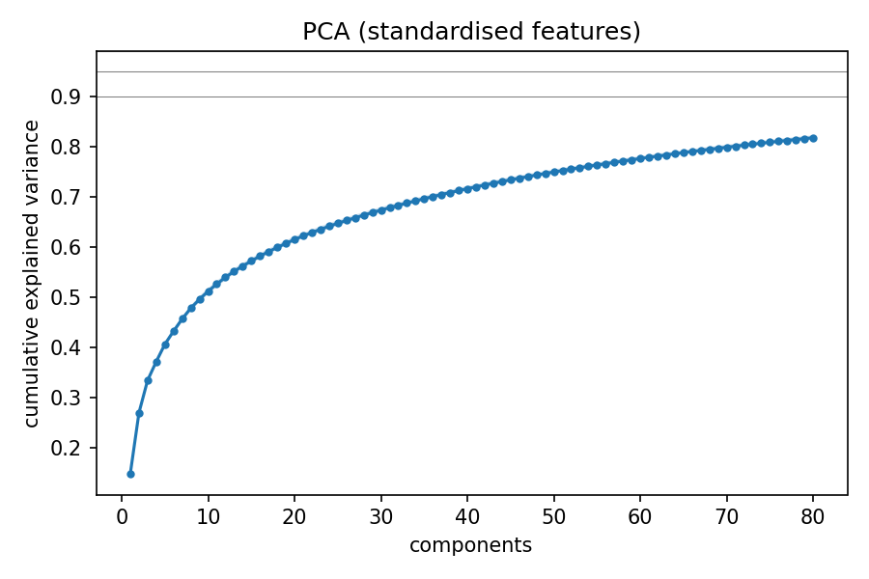
Figure 4: pca_explained_variance
Limitations. PCA is unsupervised: the highest-variance directions need not be the ones related to the target. Standardisation gives a rare, mostly-zero bin the same unit variance as a dense bin, which can inflate noise directions. Components mix bone and air bins and are not directly interpretable.

9.2 Partial Least Squares (PLS)
PLS is a supervised linear extraction. The first weight vector maximises the covariance with the target rather than the variance of the projection:
w₁ = argmax_w Cov(Xw, y)² subject to ‖w‖ = 1 ⇒ w₁ ∝ Xᵀy
The NIPALS algorithm then computes the scores t = Xw, the loadings p = Xᵀt / (tᵀt), deflates X ← X − tpᵀ, and repeats. Components are sequential, so the first n components of a fit with 80 are identical to a fit with n, which is why the script fits once and slices. Since Cov(Xw, y) = Corr · SD(Xw) · SD(y), PLS trades variance against predictiveness, whereas PCA ignores the target. PLS must be fitted inside each training fold.

9.3 Linear Discriminant Analysis (LDA)
LDA needs discrete classes. The target here is continuous, so the script bins it into K = 10 quantile bins using training-fold quantiles. This is an exploratory use: it discards the ordering of the bins and the bin edges are a modelling choice.
S_W = ∑_c ∑_{i∈c} (xᵢ − μ_c)(xᵢ − μ_c)ᵀ (within-class scatter)
S_B = ∑_c N_c (μ_c − μ)(μ_c − μ)ᵀ (between-class scatter)
J(w) = (wᵀ S_B w) / (wᵀ S_W w) (Fisher's criterion)
Maximising J leads to the generalised eigenproblem S_B w = λ S_W w, equivalently S_W⁻¹ S_B w = λ w. S_B is a sum of K rank-one terms whose weighted deviations sum to zero, so rank(S_B) ≤ K − 1. Hence at most K − 1 = 9 discriminant components exist, which is why LDA appears with 5 and 9 components only.
Assumptions. Classes are Gaussian with a common covariance matrix. With strongly collinear features S_W is near-singular, so the SVD solver is used. Because LDA is supervised, a leak is possible if it is fitted on data that include validation patients, so it is fitted on the training fold only.

9.4 t-SNE and UMAP (visualization only)
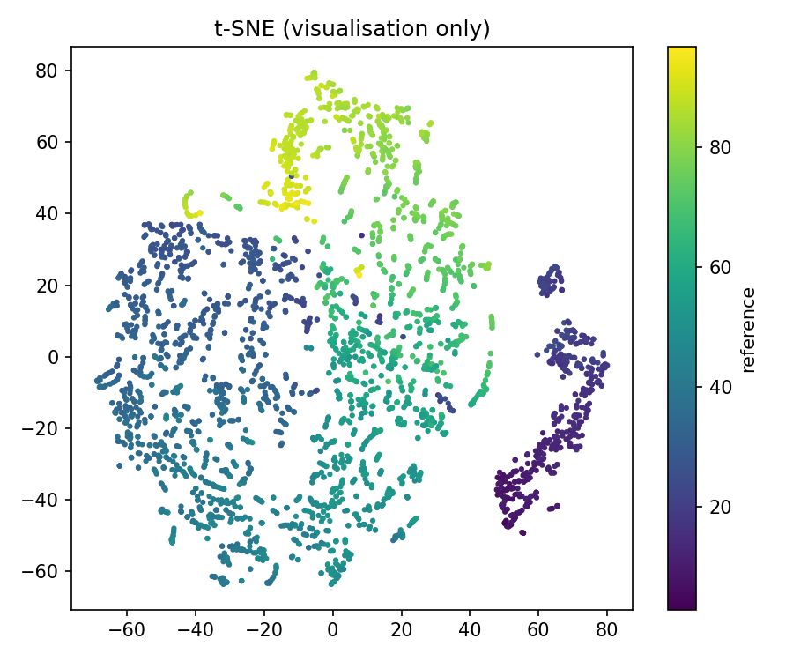
Figure 5: embedding_visualisation
t-SNE converts distances into neighbour probabilities. In the high-dimensional space:
p_{j|i} = exp(−‖xᵢ − xⱼ‖² / 2σᵢ²) / ∑_{k≠i} exp(−‖xᵢ − xₖ‖² / 2σᵢ²), pᵢⱼ = (p_{j|i} + p_{i|j}) / 2N
The bandwidth σᵢ is set so that the perplexity 2^{H(Pᵢ)} equals a chosen value (30 here). In the low-dimensional map a heavy-tailed Student-t kernel is used:
qᵢⱼ = (1 + ‖yᵢ − yⱼ‖²)⁻¹ / ∑_{k≠l} (1 + ‖yₖ − yₗ‖²)⁻¹
The map minimises KL(P ‖ Q) = ∑ pᵢⱼ log(pᵢⱼ / qᵢⱼ) by gradient descent, with gradient 4 ∑ⱼ (pᵢⱼ − qᵢⱼ)(yᵢ − yⱼ)(1 + ‖yᵢ − yⱼ‖²)⁻¹. The heavy tails let moderately distant points sit far apart, which relieves crowding. The exact method costs O(N²); the Barnes–Hut variant costs O(N log N).
UMAP builds a weighted k-nearest-neighbour graph with fuzzy membership strengths v_{j|i} = exp(−(d(xᵢ,xⱼ) − ρᵢ)/σᵢ), symmetrised as vᵢⱼ = v_{j|i} + v_{i|j} − v_{j|i}v_{i|j}, and finds a low-dimensional layout whose weights wᵢⱼ = (1 + a‖yᵢ − yⱼ‖²ᵇ)⁻¹ minimise the cross-entropy between the two weight sets. Its main hyperparameters are n_neighbors and min_dist (McInnes et al., 2018).
Why they are not used for prediction here. Standard t-SNE learns no mapping that can be applied to new patients; it is stochastic; and its output depends strongly on perplexity and initialisation. Cluster sizes and between-cluster distances are not meaningful. UMAP can transform new points, but using either method inside a predictive pipeline would require its own validation under the patient-grouped protocol. In this study they are used only to view the structure of the data.

10. Selection stability
Stability asks whether a method selects the same features when the training sample changes. Here the "samples" are the training parts of the outer folds, so m = 5 selected sets of equal size k per method and k.
Jaccard similarity of two selected sets A and B:
J(A, B) = |A ∩ B| / |A ∪ B| (0 = disjoint, 1 = identical)
Kuncheva index (Kuncheva, 2007), for two sets of size k out of n features, with r = |A ∩ B|:
KI(A, B) = ( r · n − k² ) / ( k · (n − k) )
If two sets of size k were drawn at random, the expected overlap is E[r] = k²/n, which makes the numerator zero, so KI = 0 corresponds to chance and KI = 1 to identical sets. Jaccard has no such correction: its chance level depends on k. For n = 379 features, an approximation (E[J] ≈ E[r] / (2k − E[r])) gives:
k | Expected overlap k²/n | Approximate chance Jaccard
10 | 0.26 | 0.013
40 | 4.2 | 0.056
80 | 16.9 | 0.118
160 | 67.5 | 0.268
Selection frequency of feature j is πⱼ = (1/m) ∑ over folds of 1[j ∈ S_fold]. Features with πⱼ = 1 are always selected; the number of features ever selected shows how much the selection moves.
Limitations. The five training sets overlap by roughly three quarters, so the selected sets are not independent samples and stability is biased upwards. With m = 5 there are only 10 pairs. Stability is also not accuracy: a method can be perfectly stable and uninformative, as with the variance filter.

11. Statistical comparison
Fold scores are not independent: any two training sets share most of their patients. A naive paired t-test on the 5 differences underestimates the variance and is anticonservative.
Corrected resampled t-test (Nadeau and Bengio, 2003). For paired differences dⱼ = RMSE_method − RMSE_baseline over J splits:
t = d̄ / √[ (1/J + n_test/n_train) · s_d² ], df = J − 1
CI₉₅ = d̄ ± t_{0.975, J−1} · √[ (1/J + n_test/n_train) · s_d² ]
The extra term n_test/n_train (about 1/4 for 5-fold CV) accounts for the overlap of training sets. A negative d̄ means the method beat the baseline.
Holm–Bonferroni correction controls the probability of any false positive across m comparisons. Sort the p-values p(1) ≤ … ≤ p(m) and set:
p̃(i) = max_{j ≤ i} min( 1, (m − j + 1) · p(j) )
Limits of this analysis. With J = 5 the test has little power; the unit of replication is 77 patients, not 5 folds; the comparison family (152 method-by-k tests) includes many hopeless configurations such as k = 5; and choosing each method's best k on the same CV makes its comparison with the baseline optimistic.

12. Results so far
All values come from the uploaded result files. RMSE is in target units. CV values are means over 5 patient-grouped folds.

12.1 Reference points (CV)
Model | RMSE | Note
Mean predictor | 22.55 (SD 0.61), R² −0.03 | Floor
Ridge, all features | about 10.38 (derived) | One fold kept 378 columns (10.67), four kept 379 (10.30, SD 1.21)
HGB, all features | about 6.93 (derived) | One fold 6.00, four folds 7.17 (SD 2.49)
The baseline appears as two rows in summary.csv because its k is the number of surviving columns, which differed by fold. This is a bookkeeping flaw in the reference script (Section 13).

12.2 CV RMSE versus number of selected features
HGB
Method | k=5 | k=10 | k=20 | k=40 | k=80 | k=160
variance | 21.1 | 20.5 | 20.0 | 18.0 | 12.0 | 6.8
f_test | 18.8 | 18.7 | 18.8 | 14.0 | 10.0 | 7.8
spearman | 18.7 | 18.8 | 18.6 | 14.4 | 11.4 | 7.4
mutual_info | 20.7 | 17.7 | 13.4 | 11.6 | 8.0 | 6.5
corr_filter | 18.7 | 18.8 | 16.3 | 12.8 | 9.5 | 7.4
rfe_ridge | 13.6 | 10.3 | 8.6 | 7.7 | 7.1 | 6.9
lasso_path | 14.8 | 11.4 | 9.6 | 7.6 | 7.0 | 6.8
elastic_net | 14.8 | 11.7 | 9.2 | 7.3 | 7.1 | 6.8
rf_impurity | 13.6 | 12.1 | 9.2 | 7.8 | 7.2 | 7.0
rf_permutation | 13.2 | 11.1 | 9.7 | 7.9 | 6.9 | 6.9
Ridge
Method | k=5 | k=10 | k=20 | k=40 | k=80 | k=160
variance | 21.0 | 20.8 | 20.4 | 19.8 | 17.5 | 11.8
f_test | 18.9 | 18.9 | 18.9 | 15.1 | 12.8 | 11.0
spearman | 19.4 | 18.9 | 18.7 | 14.8 | 13.4 | 10.9
mutual_info | 21.4 | 21.1 | 19.6 | 16.2 | 13.2 | 11.0
corr_filter | 19.0 | 18.9 | 17.0 | 14.5 | 12.4 | 10.9
rfe_ridge | 14.5 | 12.6 | 11.5 | 10.6 | 10.5 | 10.4
lasso_path | 15.6 | 12.9 | 12.1 | 10.8 | 10.2 | 10.4
elastic_net | 18.0 | 15.1 | 11.5 | 10.7 | 10.4 | 10.4
rf_impurity | 19.1 | 17.9 | 14.0 | 12.2 | 11.0 | 10.6
rf_permutation | 18.9 | 17.8 | 14.8 | 13.2 | 11.4 | 10.5
Reading these tables. At small k the univariate filters sit close to the mean predictor (about 22.6), while RFE, the Lasso path, ElasticNet and the random-forest methods reach roughly 7 to 10 (HGB) already at k = 40. The filters have not plateaued by k = 160, so the grid needs extending. SFS is omitted because of the defect described in Section 7.2.
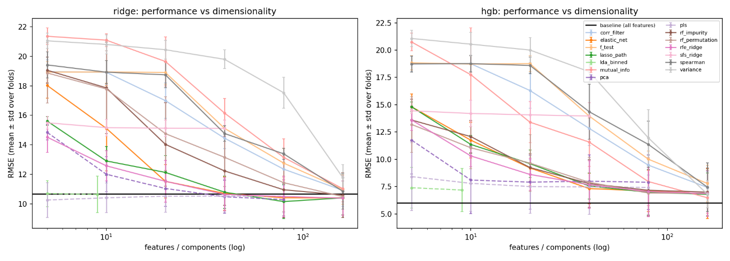
Figure 6: performance_vs_k

12.3 Extraction and paired tests
Model | Method | Components: RMSE
HGB | PCA | 5: 11.8, 10: 8.1, 20: 7.9, 40: 8.0, 80: 7.9
HGB | PLS | 5: 8.4, 10: 7.8, 20: 7.5, 40: 7.5, 80: 7.4
HGB | LDA (10 bins) | 5: 7.4, 9: 7.2
Ridge | PCA | 5: 14.8, 10: 12.0, 20: 11.0, 40: 10.5, 80: 10.3
Ridge | PLS | 5: 10.3, 10: 10.4, 20: 10.5, 40: 10.5, 80: 10.5
Ridge | LDA (10 bins) | 5: 10.7, 9: 10.6
Paired corrected tests against the baseline show:
- At each method's best k, every HGB confidence interval includes zero (except SFS, which is defective).
- Counting (method, k) pairs whose 95% interval excludes zero, selection methods without SFS give for HGB: k=5: 10, k=10: 10, k=20: 8, k=40: 7, k=80: 2 (none at k=160). For Ridge: 10, 9, 9, 5, 5 and 1 at k=160.
- No comparison reaches significance after Holm correction except the defective SFS configurations for Ridge.

12.4 Stability at k = 40
Method | Jaccard | Kuncheva | Always selected | Ever selected
variance | 0.91 | 0.95 | 36 | 43
spearman | 0.90 | 0.94 | 35 | 44
f_test | 0.89 | 0.93 | 36 | 45
sfs_ridge | 0.89 | 0.93 | 36 | 45
mutual_info | 0.84 | 0.90 | 33 | 48
corr_filter | 0.77 | 0.85 | 28 | 51
lasso_path | 0.63 | 0.74 | 21 | 62
rf_impurity | 0.61 | 0.73 | 23 | 64
elastic_net | 0.58 | 0.70 | 22 | 67
rf_permutation | 0.49 | 0.62 | 17 | 74
rfe_ridge | 0.48 | 0.61 | 17 | 77
The SFS row duplicates the F-test row in every column, which confirms that SFS at k = 40 returned the F-test top 40. Filters are the most stable and are also the weakest at small k; the multivariate methods are less stable but far more accurate at small k. Chance Jaccard at k = 40 is about 0.06, so even the least stable method is well above chance.
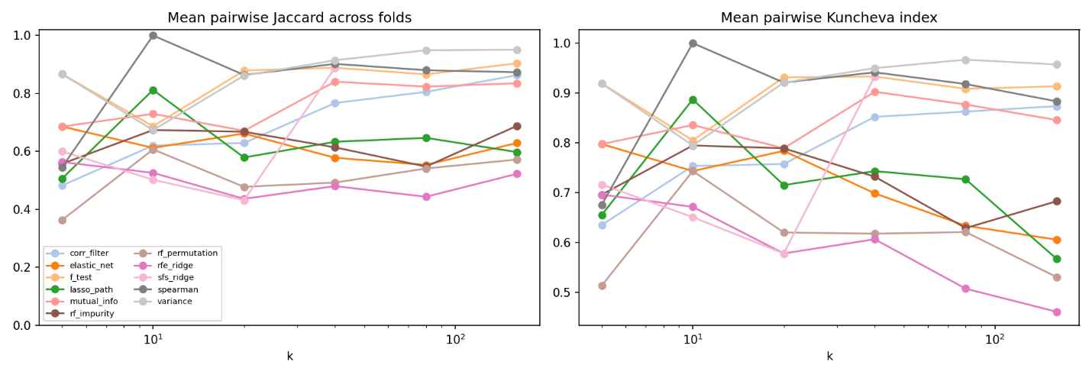
Figure 7: stability_vs_k
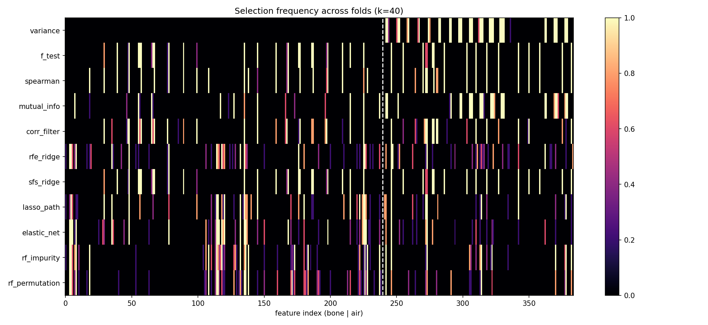
Figure 8: selection_frequency
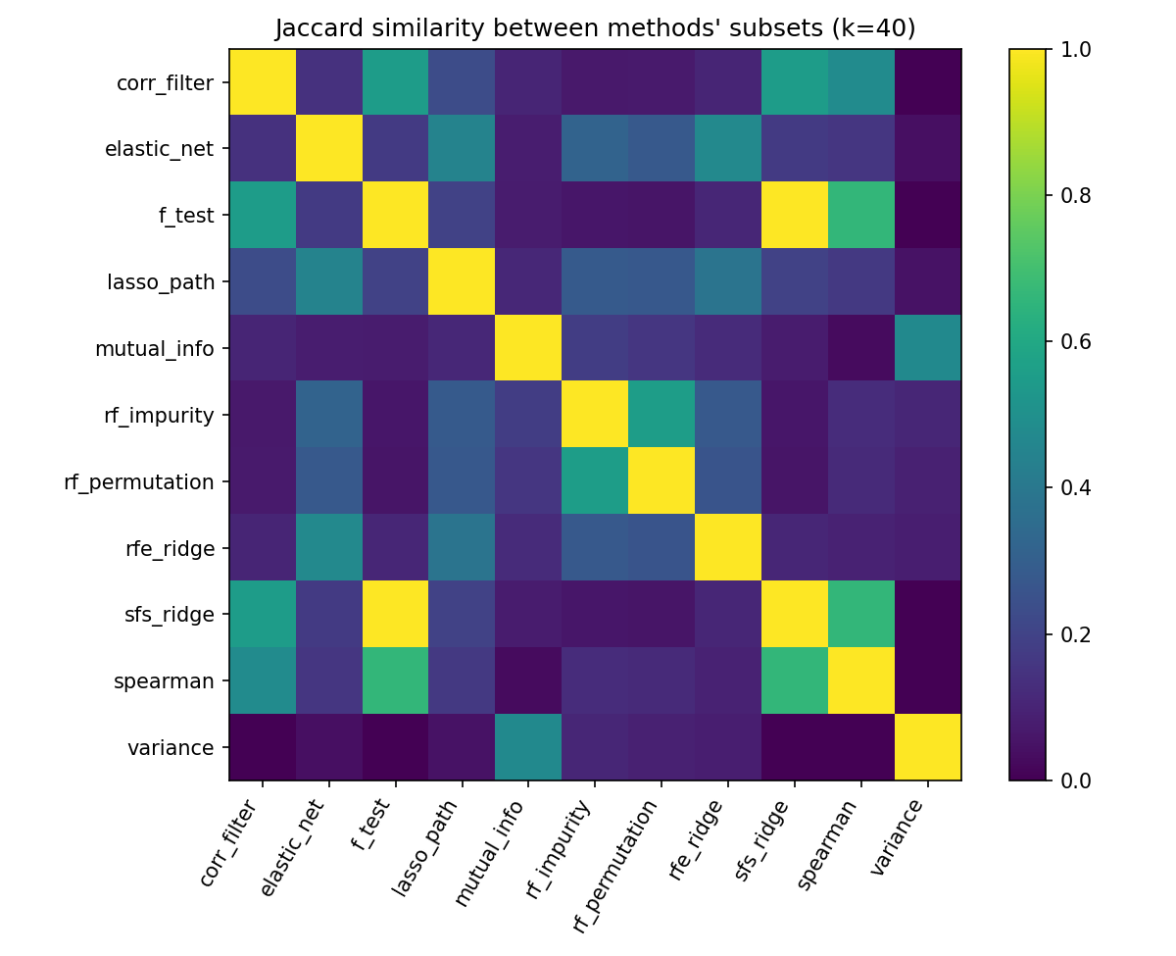
Figure 9: method_similarity

12.5 Final held-out test (single run, 20 patients)
Model | Method (k) | RMSE | MAE | R²
– | Mean predictor | 21.90 | 18.50 | −0.04
Ridge | All features (379) | 8.93 | 6.44 | 0.828
Ridge | ElasticNet (160) | 8.94 | 6.44 | 0.827
Ridge | PCA (80) | 8.95 | 6.48 | 0.827
Ridge | LDA (9) | 9.01 | 6.51 | 0.824
Ridge | RFE (160) | 9.10 | 6.55 | 0.821
HGB | All features (379) | 5.24 | 2.78 | 0.941
HGB | PCA (80) | 4.94 | 2.92 | 0.947
HGB | RFE (160) | 5.05 | 2.71 | 0.945
HGB | PLS (80) | 5.06 | 2.70 | 0.945
HGB | RF permutation (160) | 5.32 | 2.84 | 0.939
HGB | ElasticNet (160) | 5.53 | 2.83 | 0.934
HGB | LDA (9) | 5.77 | 2.49 | 0.928
HGB | Mutual information (160) | 6.04 | 2.94 | 0.921
HGB | Correlation filter (160) | 6.17 | 3.12 | 0.918
Interpretation, within the evidence.
- HGB is far better than Ridge for every method (RMSE about 5 to 6 versus 9 to 10), so the choice of benchmark model matters more than the choice of selector.
- For Ridge, no reduced representation improves on the baseline.
- CV and test rankings of methods agree for Ridge (rank correlation about 0.84, derived) but not for HGB (about 0.03, derived). For example PCA is last for HGB in CV and first on the test set. Differences between methods for HGB are within the noise of 77 development patients and 20 test patients, so no ranking of methods can be claimed.
- LDA with HGB has the lowest MAE but a worse RMSE than the baseline, so its errors are heavy-tailed. This needs an explanation before it is reported.

12.6 Computational cost
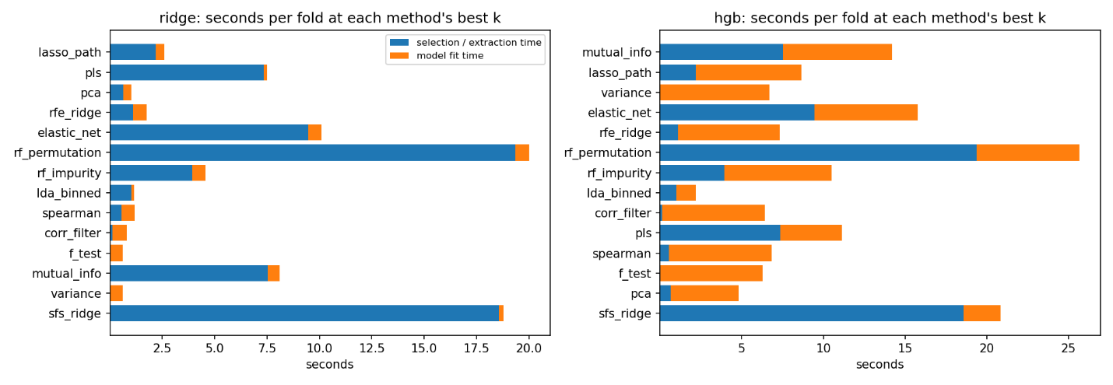
Figure 10: computational_cost
- What the figure shows: the per-fold selection and fit times for each method at its best k, for Ridge and HGB. For example, RF permutation takes 19.4 s and SFS 18.6 s, while the filters take under a second.
- Cost against benefit: ElasticNet, RFE and the Lasso path give the best small-k accuracy in Section 12.2 for 1 to 9.5 s of selection time. RF permutation costs the most without being more accurate.
- Caveats: methods are timed at different k, they use different row subsamples, and the timings come from a single run.
All numbers come from your best_k_per_method.csv and summary.csv. The roughly 62–65% HGB fit-time reduction versus the all-feature baseline (about 17.7 s) is my arithmetic, and the text marks it as derived.

13. Known issues and limitations
- SFS defect. Pool size equals k_max (40), so the k = 40 selection is the F-test top 40. Increase the pool well beyond k_max.
- Baseline bookkeeping. The baseline k varies by fold (378 or 379), splitting it into two summary rows. Record the surviving-column count separately and label the baseline once.
- Grid edge. Most best-k values are at the top of the grid (160 features; PCA and PLS at 80). The filters have not plateaued.
- Optimism from choosing k. Selecting each method's best k on the same CV that is compared with the baseline biases the comparison in its favour. Pre-specify matched k values (for example 20, 40, 80, 160) as the comparison family.
- Holm family. 152 tests, many at hopeless settings, make the correction both harsh and arbitrary.
- Replication. One repeat of 5-fold CV over 77 patients. Stability estimates use 5 overlapping sets.
- Test-set reuse. The final stage was run before the CV evidence had been reviewed. Any pipeline change made after seeing these test numbers means the test patients influenced the design, so this must be disclosed, or a fresh evaluation protocol used.
- Sentinel handling. −0.25 is currently kept as an ordinary value in every method. This is a decision still to be justified, for example against an indicator-feature alternative.
- LDA is exploratory. The target is quantile-binned into 10 classes, which is a modelling choice.
- Patient dependence. Patient identity explains 47% of target variance and adjacent slices are near-duplicates, so effective sample size is much closer to the number of patients than to the number of rows.
- Provenance. The pipeline is reference code. Stage 1 questions and written EDA analysis are still outstanding, and the study is not complete until the methods are implemented and defended independently.

14. Suggested next steps
- Answer the Stage 1 questions and write the EDA analysis, including which column is near-constant and which patients carry its non-zero values.
- Fix the SFS pool, the baseline bookkeeping and the k grid (extend to about 240 and 320).
- Run at least three repeats of grouped CV, and pre-specify the comparison family.
- Save per-patient predictions so that a patient-level bootstrap interval can be computed on the test set.
- Decide and document how the −0.25 sentinel is handled.
- Write each README section only after its results are verified, including the failed or defective experiments listed above.

15. References
Check every citation against the original source before including it in the README.
- Hoerl, A. E. and Kennard, R. W. (1970). Ridge regression: biased estimation for nonorthogonal problems. Technometrics, 12(1).
- Fisher, R. A. (1936). The use of multiple measurements in taxonomic problems. Annals of Eugenics, 7(2).
- Holm, S. (1979). A simple sequentially rejective multiple test procedure. Scandinavian Journal of Statistics, 6(2).
- Tibshirani, R. (1996). Regression shrinkage and selection via the lasso. Journal of the Royal Statistical Society B, 58(1).
- Friedman, J. H. (2001). Greedy function approximation: a gradient boosting machine. Annals of Statistics, 29(5).
- Breiman, L. (2001). Random forests. Machine Learning, 45.
- Guyon, I., Weston, J., Barnhill, S. and Vapnik, V. (2002). Gene selection for cancer classification using support vector machines. Machine Learning, 46.
- Nadeau, C. and Bengio, Y. (2003). Inference for the generalization error. Machine Learning, 52.
- Efron, B., Hastie, T., Johnstone, I. and Tibshirani, R. (2004). Least angle regression. Annals of Statistics, 32(2).
- Kraskov, A., Stögbauer, H. and Grassberger, P. (2004). Estimating mutual information. Physical Review E, 69.
- Zou, H. and Hastie, T. (2005). Regularization and variable selection via the elastic net. Journal of the Royal Statistical Society B, 67(2).
- Kuncheva, L. I. (2007). A stability index for feature selection. Proceedings of the IASTED International Conference on Artificial Intelligence and Applications.
- Strobl, C., Boulesteix, A.-L., Zeileis, A. and Hothorn, T. (2007). Bias in random forest variable importance measures. BMC Bioinformatics, 8.
- van der Maaten, L. and Hinton, G. (2008). Visualizing data using t-SNE. Journal of Machine Learning Research, 9.
- McInnes, L., Healy, J. and Melville, J. (2018). UMAP: uniform manifold approximation and projection for dimension reduction. arXiv:1802.03426.
- Original dataset: UCI Machine Learning Repository, "Relative location of CT slices on axial axis" (Graf et al., 2011). Confirm the exact citation on the UCI page.

